**User Interface Project (A Pre-Planned document)**

**Mukesh SA**

**TOPIC: Flight Ticket booking system ROLL: CB.EN.U4CYS21046**

We have explored a lot many flight systems like Emirates, Qatar airways, Air India etc... To get an idea on how the outline of a basic flight booking system looks like.

Basically when we create a website or a user interface for the users, there are three steps that we used to approach:

**1. User analysis:**

A Flight ticket booking system has so many processes where the users should use like:

1) Choosing a destination

2) Check the availability of the seats

3) Booking tickets

4) Payment

5) Cancel Tickets and refund process

**2. System prototyping:**

What we actually want is to check how users see and interact with the software. In this Flight

management system, we have to make buttons clearer and visible. Also we want to display the prices

prominently because it is one of the main criteria on which most visitors make their choice. We want to

bring in more information about the destinations for the visitors to explore and choose.

**3. Interface evaluation:**

This evaluation is conducted by measuring the effectiveness, efficiency and satisfactory use of the

website.

A rough outline on how the front page of the website should look like using a template:

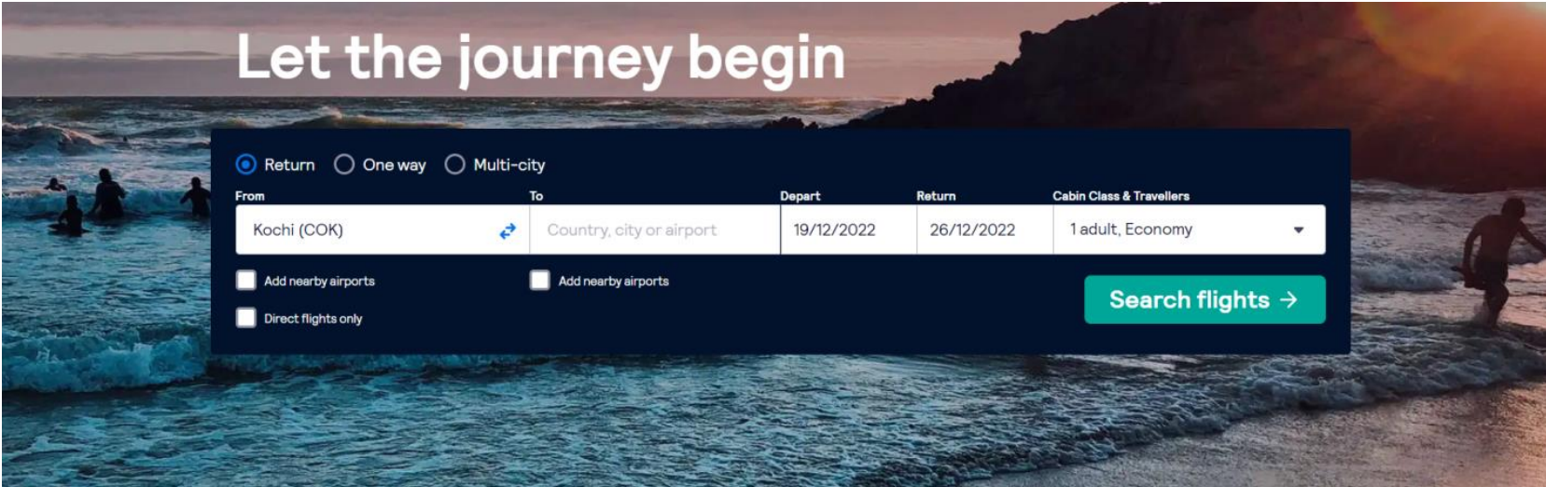

In this above outline, we can see from, to, the date of departure and cabin class etc..

When we click on search flight,

Here, passengers can choose the best flights depending on the price.

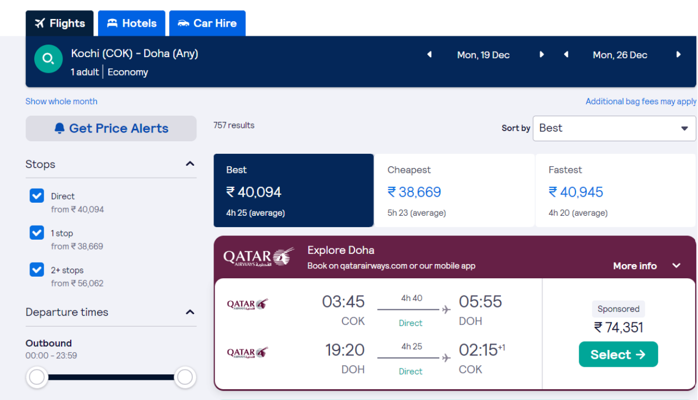

There is option on the left side, where they can choose stops between the destinations.

Passengers can choose the Destination option to explore more on the destinations.

Also to know more about the airlines, they can choose the about option.

There is also a login page which is planned to be kept separately just for the admin to use.

And also users can do the login, where there previous data will be saved after the travel, o that their

requirements can be easily accessed since its been stored in the profile.

There are so many international destinations. And there are options such as baggage rules for the flight

and also the in-flight meals which will be further implemented in the site.

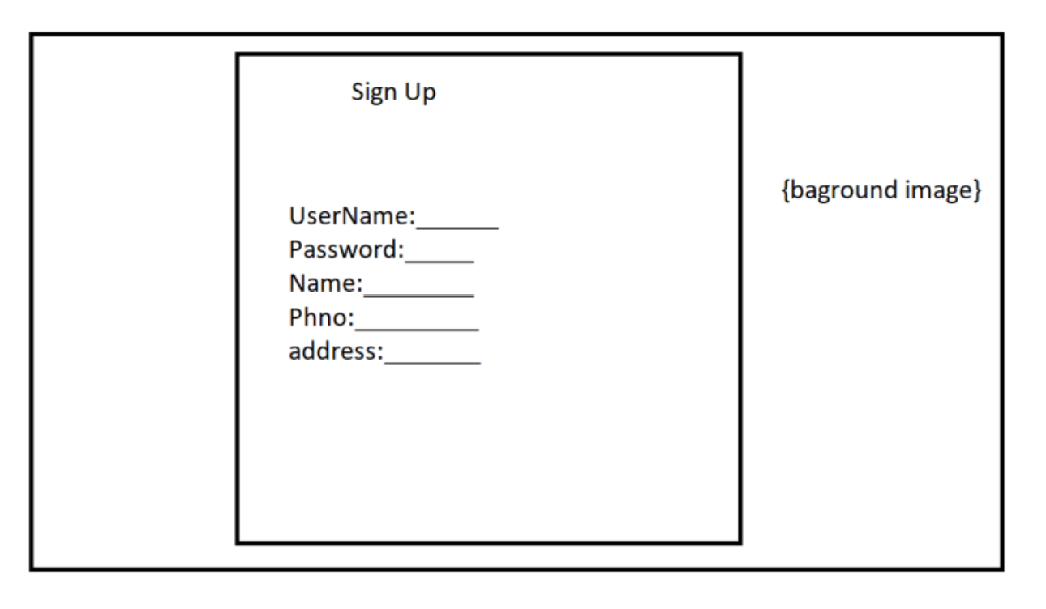

Here we can see a simple sign-up form where user is requiring enter their personal information such as

Username, password, phone number and address.

Initial prototyping using html and css (trial only)

